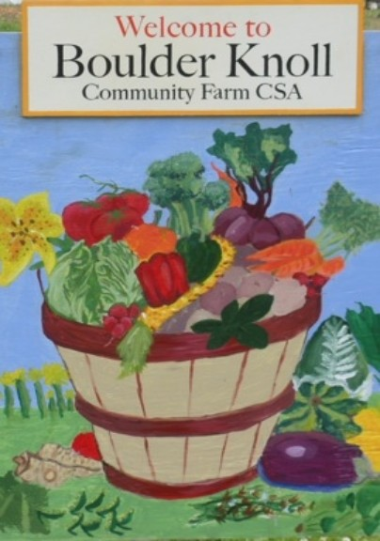
Boulder Knoll Community Farm Handbook - 2023

Welcome to the 2023 growing season at the Boulder Knoll Community Farm (BKCF). We are excited to have you join our farm community! As you know, a community garden depends on its members in many ways to guarantee its success. This is your community garden and we want it to reflect the beauty of your work.

Please review these guidelines:

A required orientation will be held for all members. (orientation date to be determined) This is an organic farm - no pesticides allowed.
We ask you to help promote the sustainability of your garden by practicing composting, mulching, and the wise use of water.
Please limit the height of the fencing around your plot to two feet. Trellises may be used to support crops.
We ask you to help keep the shed neat and organized. Clean tools before putting them away. When finished gardening for the day, return tools to the shed and lock the shed before leaving the garden.
Please report any broken tools to the farmer or farm liaison.

Keep your plot and the adjoining pathways tended. If you will be away for an extended period of time, please arrange for someone to care for your plot.
Please put weeds and dead plants into the designated compost bin. Do not leave them in the pathway. Any diseased plants or seedy or invasive weeds are to be bagged and put in the trash so as not to contaminate the gardens. Please follow the posted compost rules for proper disposal of weeds and plants.

Please do not leave the water on unattended.

The garden gates need to be closed at all times, even when you are working at the garden, to prevent wildlife from entering. Please check that all gates are closed when leaving the farm.
Please supervise children in the garden. No pets are allowed at the farm.

For your safety, garden only during daylight hours. Consider gardening in pairs or keeping a cell phone nearby if it makes you feel more comfortable.
Report theft, vandalism and unusual activities to the farmer or farm liaison. Use common courtesy, be considerate of your gardening neighbors, and enjoy.
If you have any excess produce please let the farmer know – he can arrange to have it donated.
Check the community bulletin board for information on garden events, policies, announcements and garden-related information or educational opportunities.
At the end of the gardening season, all dead plants and non-plant materials (string, wire, wood, metal, plastic, etc.) must be removed and disposed of properly and all gardens left neat and tidy.
All garden plots must be cleaned out by November 1, 2023.

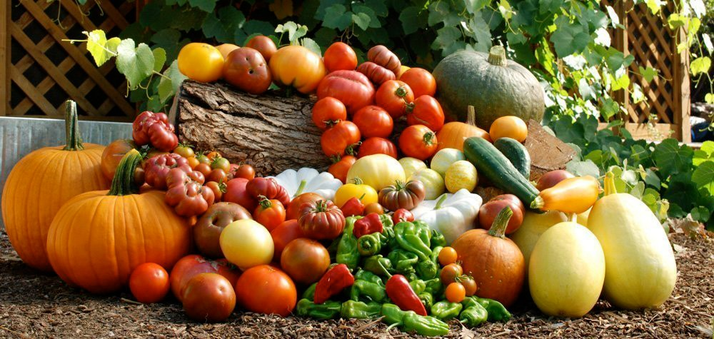
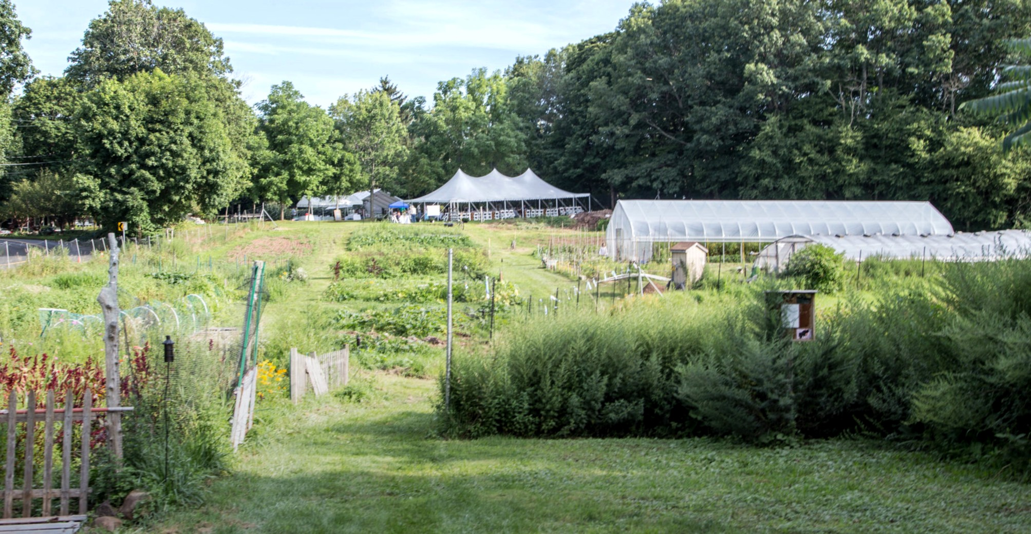

Boulder Knoll Community Farm is just one component of the mission of Friends of Boulder Knoll, but the most visible. If you are interested in being part of the governance team at the farm and our other endeavors, please consider becoming a member of the board of FOBK.

Contact information:
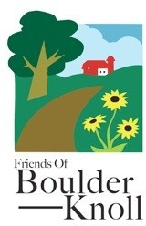
Farm Manager :
TBD

Linda Comen (liaison to FOBK Board ) linstu@gmail.com
cell: 203 605 3632

www.friendsofboulderkknoll.com www.boulderknollfarm.com

